IMIDACLOPRID ULTRA LOW VOLUME SOLUTIONS
*582/UL/M-

- Sampling. Take at least 1L

- Identity tests. As for Imidacloprid suspension concentrates 582/SC/M2/2 CIPAC K, page 74. An additional GC-MS identity test is proposed for UL formulations as outlined below:

The following instrument parameters were utilized in the GC/MS analysis:
Oven Program | 50ºC for 2 minutes  10ºC/min to 250ºC for 5 min  10ºC/min to 325ºC for 10min
Run time | 44.5min, Imidacloprid ret. time ca 20.2 min
Inlet Temperature | 325ºC
Injection Volume | 1µL
Split Injection – Split flow | 100mL/min
Flow velocity | Helium at 45cm/s
Column | Agilent HP-5ms: 30m x 250µm x 0.25µm
MSD Transfer Line | 335ºC
MS Source | 230ºC
MS Quad | 150ºC
Solvent Delay | 5min

Imidacloprid is identified in the standard and sample solution with a clear peak which matched the NIST library search for imidacloprid, containing the major ion fragment of 211 AMU.

- Imidacloprid. As for Imidacloprid suspension concentrates 582/SC/M2/2 CIPAC K, page 74 except
- An increase in run time between injections from 10 mins to 30 minutes is required. This ensures all formulation components are eluted prior to the next injection.

Figure 1. Imidacloprid standard solution analysis – GC/MS
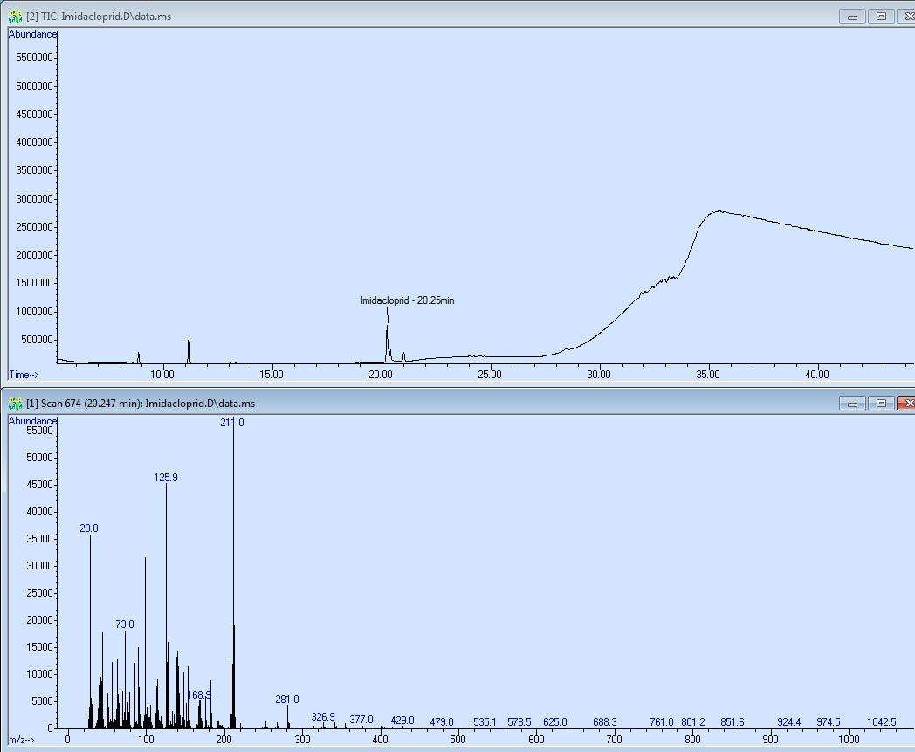
Figure 2. Formulation Analysis for Imidacloprid – GC/MS
